1. **Agenda**:
   1. In this lecture, we will see two tokens we’re using as of now which make our app authentication and authorization flow very smooth once we login into the system.
2. 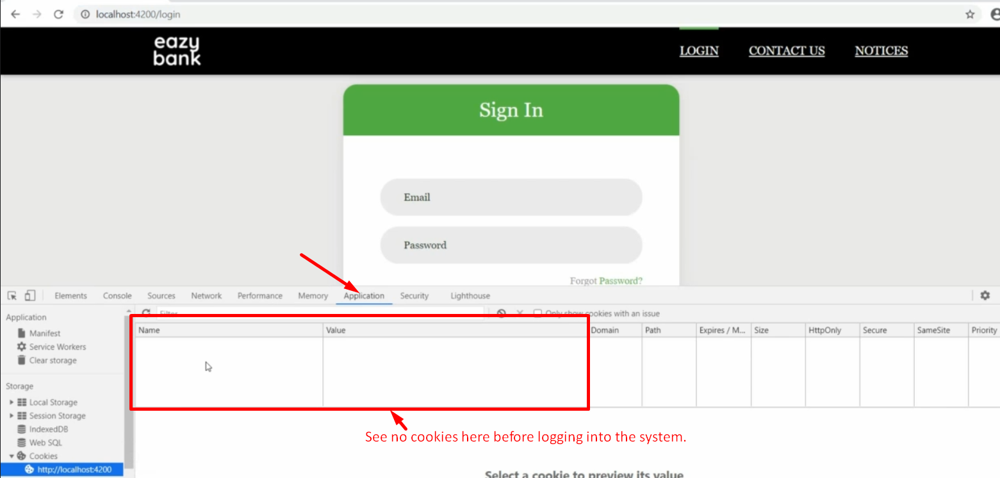
3. 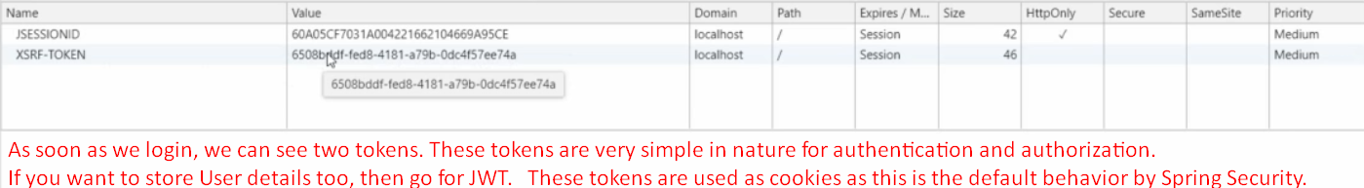
4. 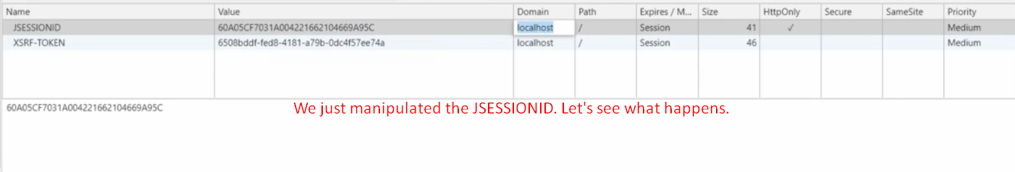
5. 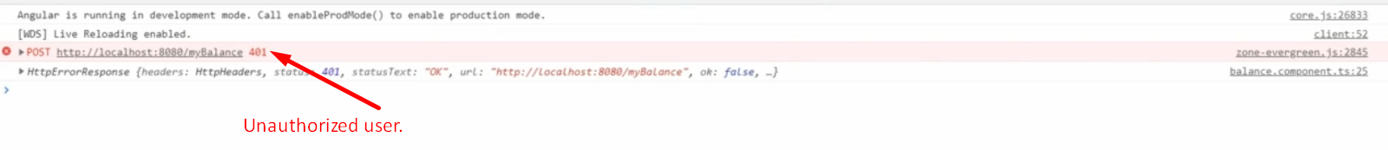
6. 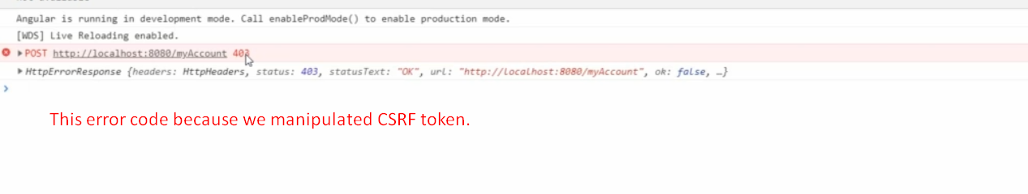
7. **Disadvantages of JESSIONID**:
   1. User Related info can’t be shared with Client App such as roles.
   2. This doesn’t support any encryption and encoding mechanism to play extra layer of security to tokens.
   3. Our server becomes stateful so in case of many microservices, difficult to share this state.